Modelling and linking Requirements in the Specific Architecture
Purpose: To define how Requirements are derived from Specifications and used as the formal layer for constraining and informing Specific Architecture (SpA) elements.
Audience: SpA maintenance team.
Version | Author | Note
1.0 | Petr Bureš, Benjamin Witsch | Revised, connection to Specifications, moved from other guidelines here.
1.1 | Petr Bure3 | Reworked from NAP reference architecture specifics to a Generic Specific Architecture

Scope
This guideline covers:
- How Requirements objects are maintained in EA
- Structure, classification, foldering, and linkage
- Excludes: How specifications are created and maintained (see Guideline 1 and 2)
- Repeats how Requirements are derived from Specifications

Role of Requirements in the SpA
Requirements:
- Translate high-level spec content into model-relevant obligations
- Are actionable and understandable within the architecture context
- Form the only linkage between Specification and architecture object

Requirements Structure in the EA Model
- Requirements are maintained in the EA model under: Supplements\Requirements, they also could be found in the folder with original specifications as well as in the views (Open question)
- The folder structure for the Requirements is not fully developed.
- Each Requirement is created as a Requirement object. Its name is derived from the specification that yielded the requirement.

Modelling Requirements in the SpA

When to Create a Requirement
- Do create when a Specification includes actionable clauses or obligations
- Do not create if the Specification only provides context or non-binding content (e.g., thresholds labelled “no feature”)

How to create a Requirement
- Create the Requirement in the Specifications view by dragging empty Requirement,
- Fill in the requirement from the Specification and
- Link it to the Specification using the Abstraction association

Naming Convention:
Format:
- Prefix from source Specification (L1, S1, KPI 3.2)
- Number within the Specification (L.1.1, S.1.2, K.3.2.1 etc. – insert a bullet after the letter, for KPI shorten to K, remove any blanks)
- Optional short label (e.g. "Establishment of NAP", “Load time web site”)
> One Requirement may reference multiple Specifications if relevant
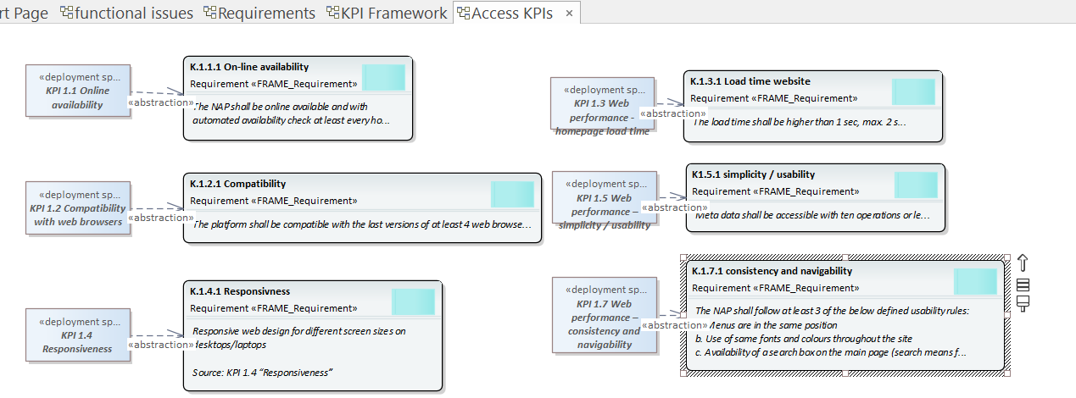

Requirement Content
Each Requirement includes:
- Name: Based on KPI or Spec reference (e.g., K.1.3.1 – Latency Threshold)
- Description: Clearly worded obligation or constraint. One clear “SHALL” style clause OR a list of items that must be fulfilled (e.g. list of data types to be published). Exception for KPIs:
  - A single sentence for one-condition thresholds
  - A list when multiple options satisfy the threshold
- Reference: Trace link to originating Specification
- Source Note: Optional note referencing original wording or clause
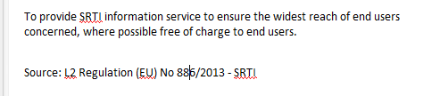
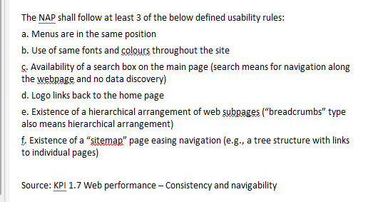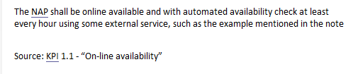

Foldering and Flow
- Created often under the associated Specification’s folder
- Requirements remain in the same folder as their associated Specification (KPI) until moved during the final step.
Once created and linked:
- Move the Requirement object to the Supplements\Requirements package.
- After it’s linked to the relevant SpA object, relocate it to the view-specific View\Specifications & Requirements subfolder.

Linking Requirements to SpA Objects

Mapping logic
To minimize redundancy, a top-down mapping order is followed:
- Subsystem
- Module
- Interface
- Actor / Agreement
- Function or Datastore
- Other objects (if needed)

Linking process
- Drag the Requirement into the target view.
- Check for any contradictions:
  - Revise the SpA object’s description, or
  - Propose an update to the Requirement and the original Specification.
- Create a “fulfilled by” link from the Requirement to the SpA object.
- Verify the link in the Traceability window.
- Remove the Requirement from the view and place it in the correct Specifications & Requirements subfolder.

Exceptions
- If there is no functionality (SpA content) to satisfy the Requirement then link the Requirement instead to a global issue “Missing functionality for the Requirement”

Examples

Motivational Layer - ITS Service:
- Purpose: Link Requirement that contain general requirements applicable to the entire service. To capture a high-level Requirement
- Example:
  - Specification: ITS Directive 2010/40/EU
  - Requirement: to establish a framework for the deployment of ITS in-road transport, ensuring interoperability and continuity of services across the EU.

Physical View - System/Subsystem/Module:
- Purpose: Link Requirement with tangible technical, performance, or design descriptions that are detailed but not specific to interfaces.
- Example:
  - Specification: mobilityDCAT-AP
  - Requirement: Use mobilityDCAT-AP for description of catalogue records.

Communications View - Interface:
- Purpose: Link Requirement with data structure, protocol, or performance descriptions relevant to specific interfaces.
- Example:
  - Specification: Commission Delegated Regulation (EU) 2015/962
  - Requirement: The interface shall be able to support the exchange of EU-wide real-time traffic information services.

Organizational View - Agreements:
- Purpose: In Agreements there is already a lot from legal acts – linking to it is natural.
- Example:
  - Specification: Commission Delegated Regulation (EU) No 886/2013
  - Requirement: data must be provided free of charge to users
- Example:
  - Specification: ITS Directive
  - Requirement: data must be provided in DATEX II format.

Functional View - Function:
- Purpose: Link Requirement with dominant functional requirements reflected in one or more functions.

Organizational View - Actors:
  - Purpose: Link Requirement identifying actors or describing activities and responsibilities. Also link actors to Requirement that are of their interest but are not directly relevant to NAP (e.g. standards for data description)

